Highcliffe School Student Bulletin
Monday 3rd – Friday 7th December 2007: Week A

Thought For The Week:
Life is either a daring adventure or nothing. Helen Keller

News Story of the Week:
Kids create 'cracking inventions'
‘See http://news.bbc.co.uk/cbbcnews/hi/uk/default.stm

Year 8 and 9 students: The Mock Trial Competition needs you! If you are interested in a career in law or love acting, this competition is for you.
Write a letter of application explaining why you think you could be either a great lawyer, defendant, magistrate, usher, legal advisor or witness for the prosecution or defence to Mrs Read. The closing date is this Wednesday (5th December). Please come and see me if you require further information in HU5. Mrs Read

Eco Club: Tuesday after school - painting boxes in Miss High's room Come and get your artistic juices flowing 3.20pm - 4.30pm! See you there!

Religious Studies Year 11 Mock Exam:
Short course - Revision notes and past papers can be found on the school Resource Bank. Use 478 for Christian Perspectives and 519 for Judaism.
In the Mock you will have a choice of two Christian perspectives questions and one Compulsory Judaism question.
For the full course - you will have four questions and will need to choose three. Topics 1,3,4,5,6,7,and 9 may be on the paper. Revision sheets have already been handed out, if you did not get one please ask. The Discovery student guides will also help, for those of you who purchased them. Good Luck!
Mrs Downie

World Challenge Parent’s Presentation: Tuesday 4th December
This will take place in the School Hall from 6:00pm – 6:45pm.
If you are interested but unable to attend for any reason, please see Miss White.

MUSIC NOTICES
Music clubs this week.
Shout! After school rehearsal: Monday 26th November 3.30-4.30pm (Ex3)
Shout! - vocal group for years 7-9: Monday lunchtimes 1.40pm in EX3
Guitar Club: Tuesday lunchtimes 1.40pm in EX2
Vocalis - Vocal group for years 10 and above: Wednesday lunchtimes 1.40pm in EX3
Harmonious Funk Jazz Band - for all wind instruments:
Wednesdays after school 3.30 - 4.30pm in EX3
Music Theory Club: Thursday lunchtimes 1.40pm in EX3


ECO NEWS:
CONGRATULATIONS TO JACK CASE, winner of the Recycool Halloween competition. Jack wrote a great poem which will be published in H2U later in the term ...and there is a sneak preview here:
You can check out Jack’s art work if you go to www.recycool.org/win.aspx. If you took part too you may also see your art work on the website! Jack won 100 trees to be planted on behalf of Highcliffe School and a book on saving the planet GREAT WORK JACK, Well done!!!

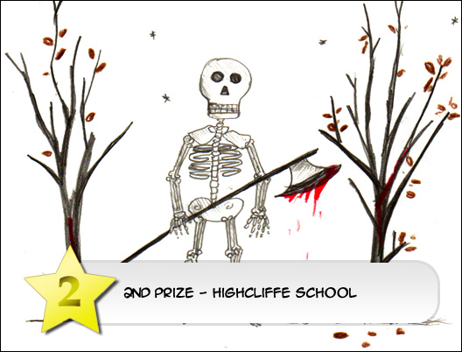

...........'There is a toxic monster with a tremendous force,
A toxic poison and a terrible cause.
To destroy all forest on planet earth,
And to bestow on life this horrific curse'.....

REMEMBER Bring in your old Yellow Pages cover and recycle the rest. We've received LOADS so far thanks to you all...Keep 'em coming!

The brown bins are multiplying!!! You will see more brown wheelie bins for plastic recycling around school now. Please put them to good use! All clear plastic bottles should be put in them (instead of bins) and they will be transformed into a new product by the recycling company.
Plastic is really a nasty material that takes years to break down, looks ugly as rubbish and kills all sorts of wildlife. If you're having a drink stop and think, loads of rubbish really does stink!

Have you ever come up a with a question that even your science teacher couldn't answer on the spot?

Questions such as Why don't penguins feet freeze? Does anything eat wasps (sound familiar???!)?

Think up a question and post it on:
http://www.the-ba.net/thebigquestion

YOU might be one of the lucky people who get their question answered by a top scientist in Science and Engineering week (coming up in March.....Watch this space!)

SO LOG ON, TYPE IN A QUESTION AND TEST THOSE SCIENTISTS!

The Year 11 Expressive Arts Practical examination is on Thursday 6th December all day in the Performance Hall. The written exam is on Friday 7th December periods 1 and 2 in the Performance Hall.

SPORTS NEWS
Dorset and Wilts Rugby Tournament: Tuesday 12th February. The boys have been entered
Girls: if you are interested in playing rugby, playing in the tournament please come to Wednesday after school practice: every Wednesday 3.20pm - 4.20pm. If we do not have a team we shall not enter!

RESULTS:
Gymnastics Tumbling Team - 2nd place overall
Year 10/11 basketball v Ringwood - A team - won 11-6
- B team - won 7-4
Year 7 netball v Grange - lost 0-4
Year 8 netball v Grange - lost 3-5

BRAIN TEASER

Five 8's = One 9
Arrange five 8's so that they equal 9.
You may not use a plus or minus sign.

Entries to be put in the Brainteaser box in Ma6 with name and tutor group before Friday7th December.

P.E. FIXTURES/PRACTICES

3rd December – 7th December 2007

 | LUNCHTIME | AFTER SCHOOL
Monday | Year 7 basketball | Year 9 netball v Wentworth (A)
Tuesday | Year 9 basketball | Year 7 basketball v Grange (A)  Years 10/11 basketball v Grange (H)  Years 9,10,11 dance club  Years 7 & 8 girls football club  Years 9,10,11 netball club
Wednesday | Year 8 basketball | Years 12/13 boys and girls 6-a-side football tournament. 1.00pm start.  Girls rugby club  Years 7 & 8 netball club  Years 9,10,11 girls football club
Thursday | Years 10/11 basketball | Town Cross-Country Championships  Year 8 basketball v Grange (H)  Year 9 basketball v Grange (A)  Years 7 & 8 netball v Avonbourne (H)
Friday | Years 10/11 girls basketball | Year 7 football v Broadstone (A)  2.30pm KO

